**Project Design Phase-II**

**Technology Stack (Architecture)**

**Technical Architecture:**

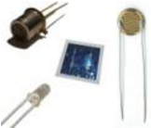

**GAS SENSOR**

**FLAME SENSOR**

**TEMPERATURE SENSOR**

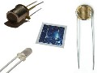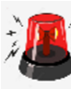

**FIRE ALARM**

**SPRINKLER**

**MICROCONTROLL**

**ER/**

**MICROPROCESSO**

**R**



**Internet of**

**Things Platform**

**Node**

**-**

**RED**

**Application**

**Cloudant**

**Database**

**Data Visualization**

1

2

4

3

5

6

7

**User**

**IBM**

**Cloud**

**Admin**

|  |  |
| --- | --- |
| **Date** | **16 October 2022** |
| **Team ID** | **PNT2022TMID08358** |
| **Project name** | **Industry Specific Intelligent Fire Management System** |
| **Maximum Marks** | **4 Marks** |